#156

Commands of it :

1. Touch :
2. Cat:

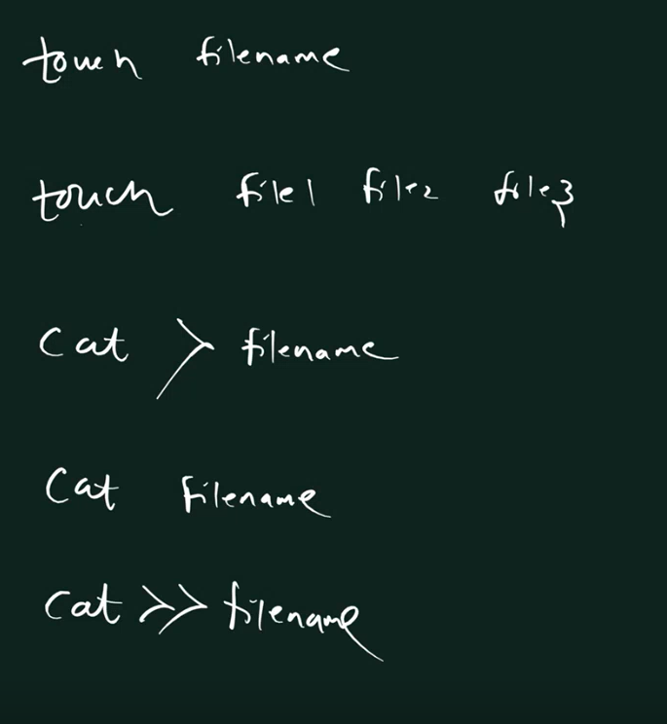

# 165

Copy :

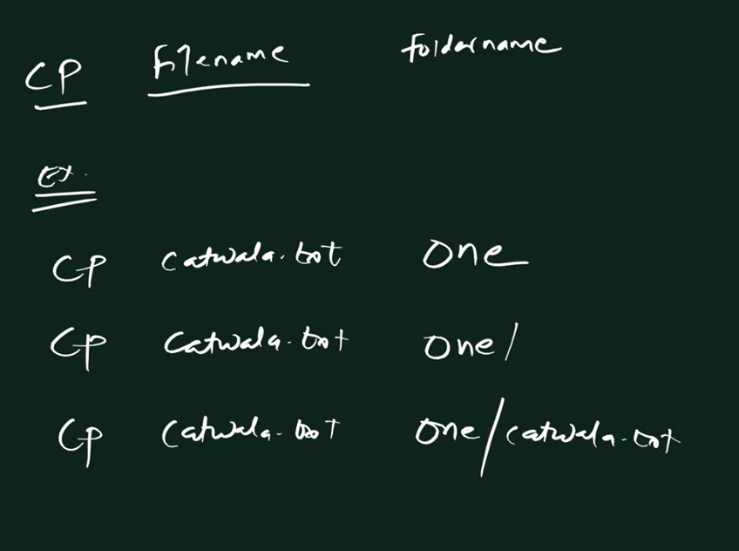

Move Command:





#244

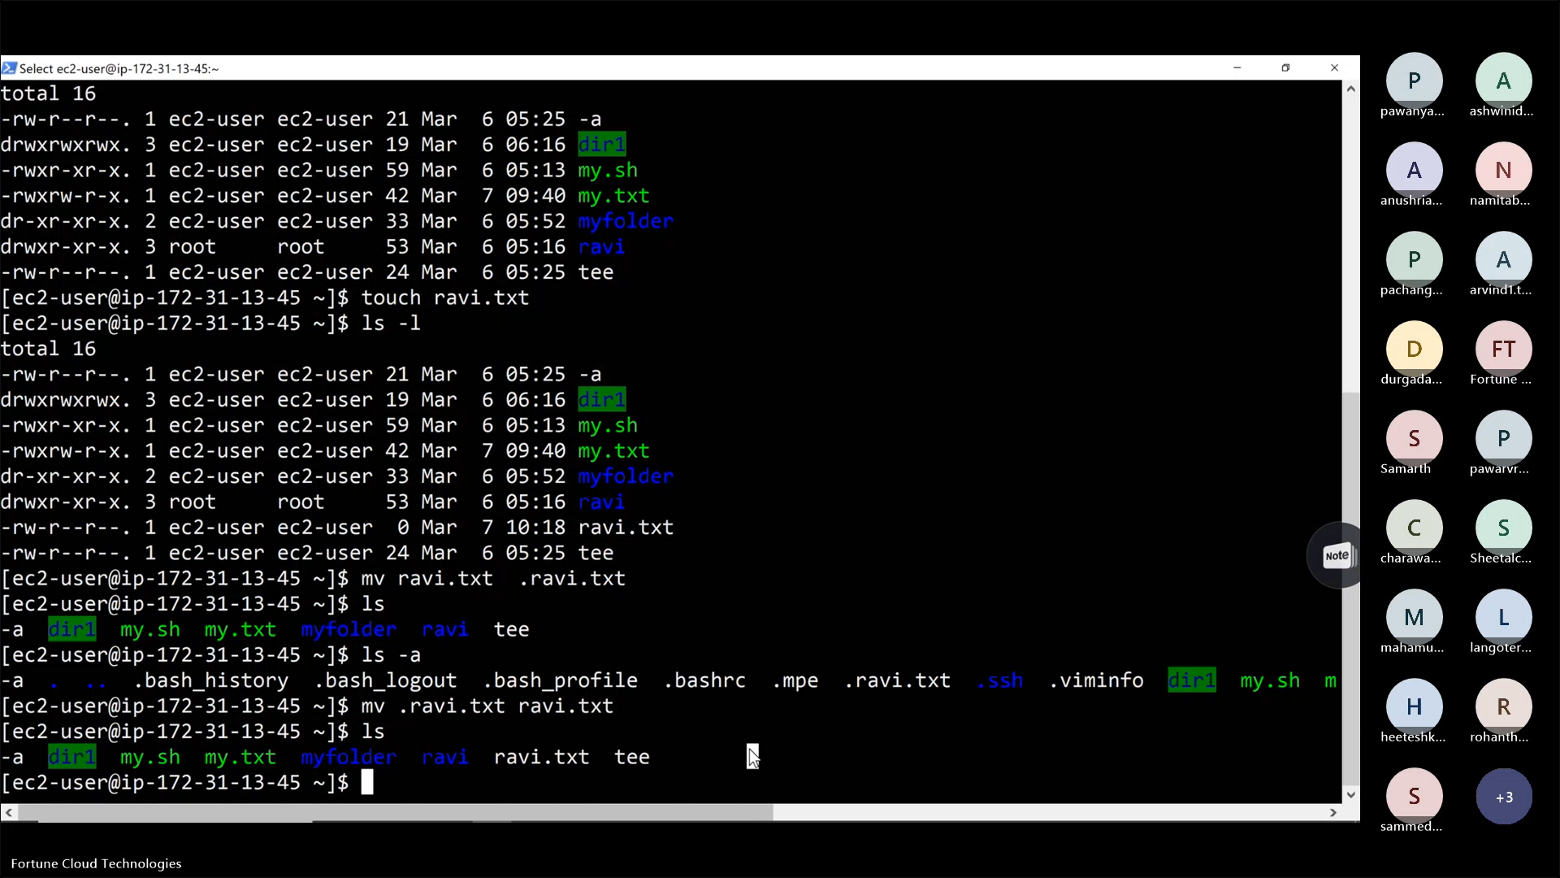

#133

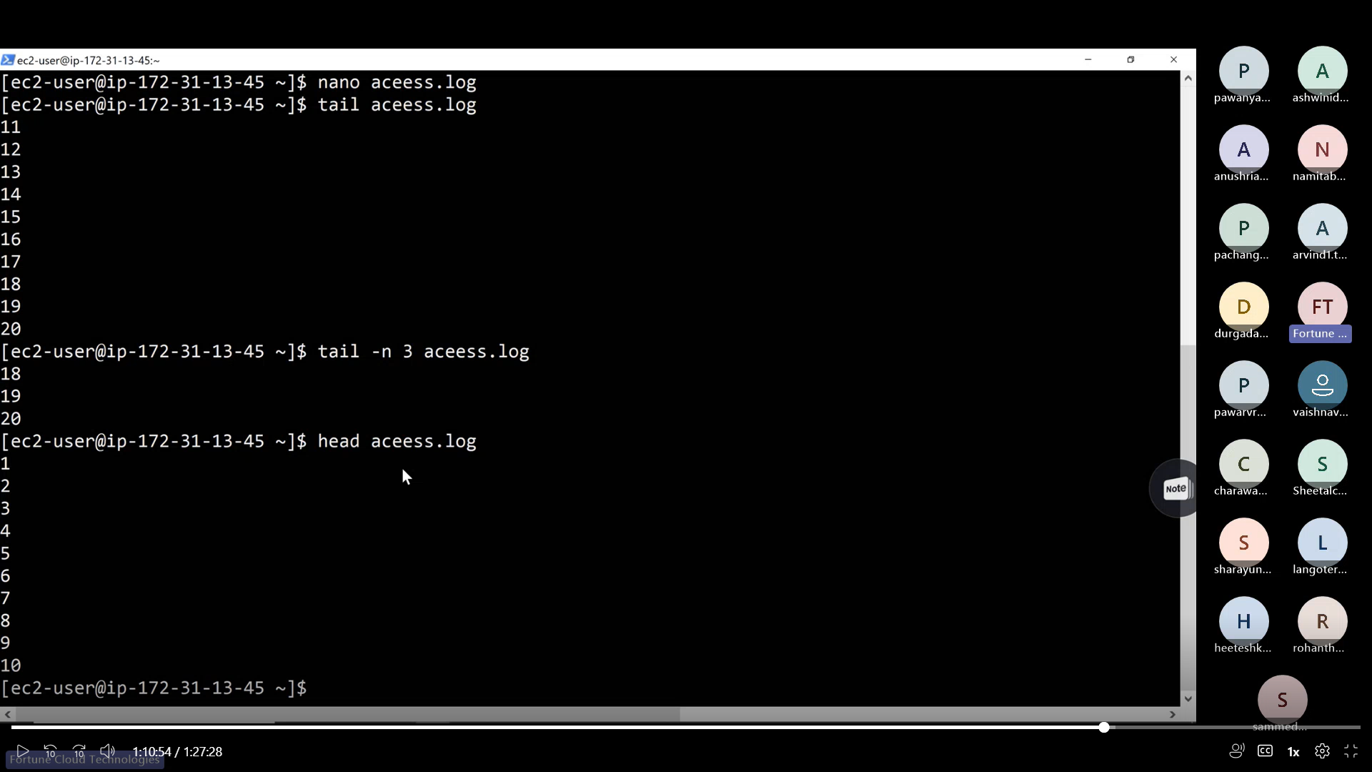

#133:part 2

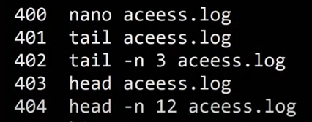

#362



#361



#222



#169

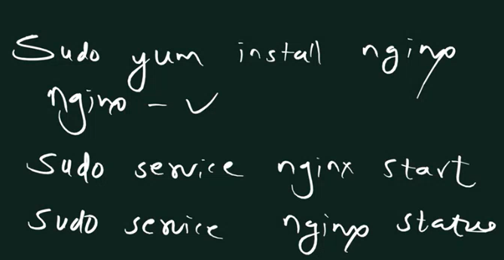

#666

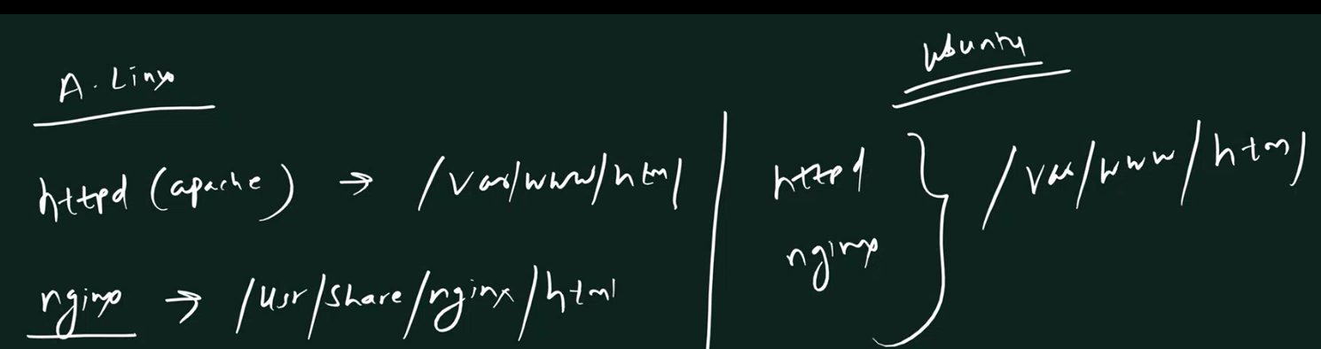

#Port Numbers:

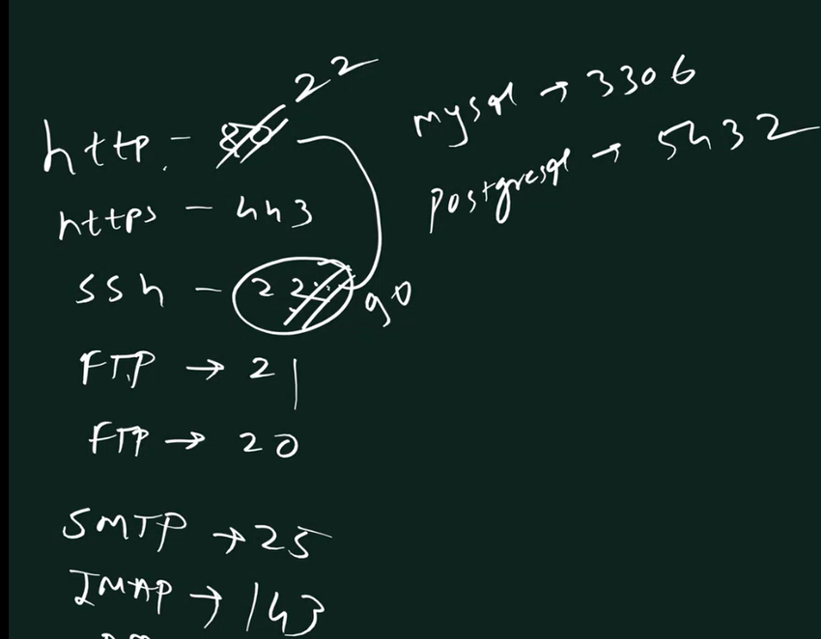

#345:Lamp

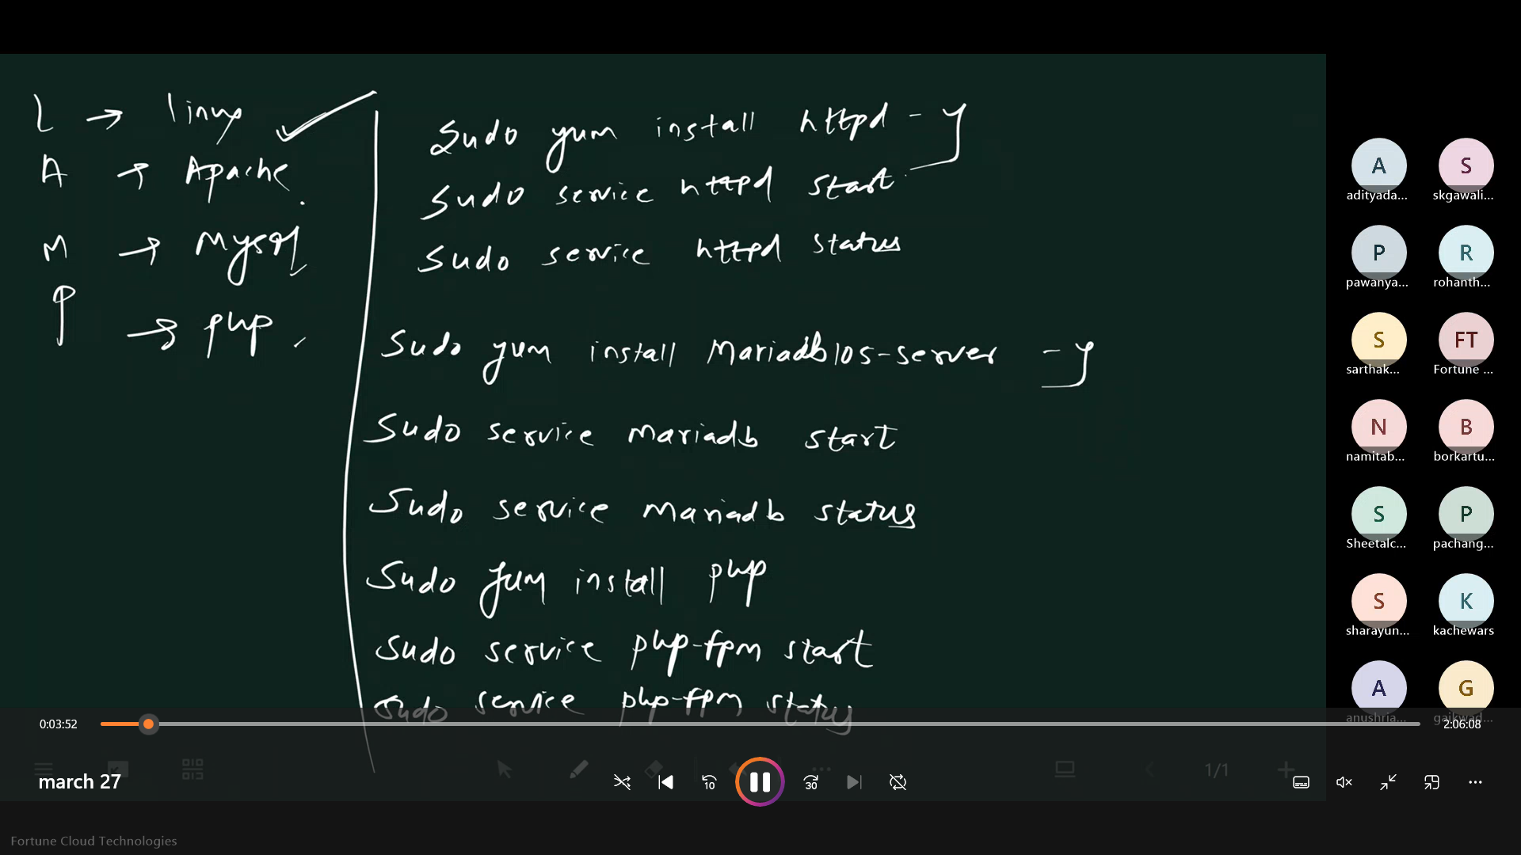

Php writeup in linux:

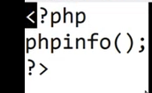

Lamp in ubuntu:

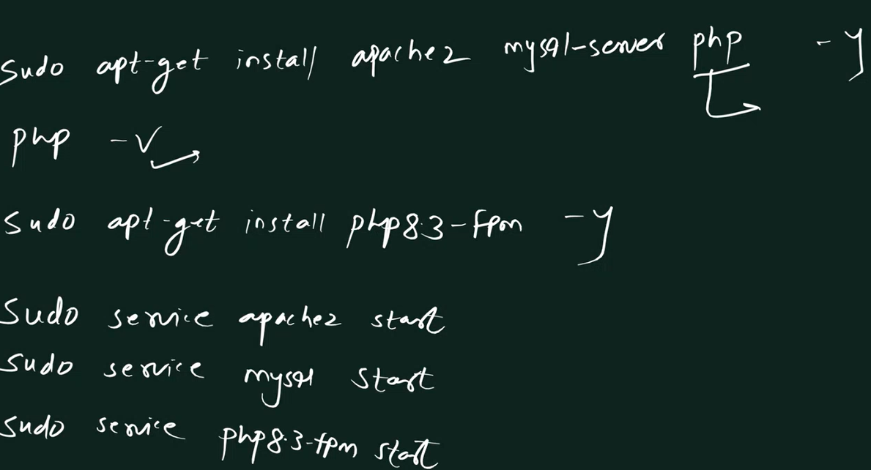

If something not works in linux:



#444lemp:

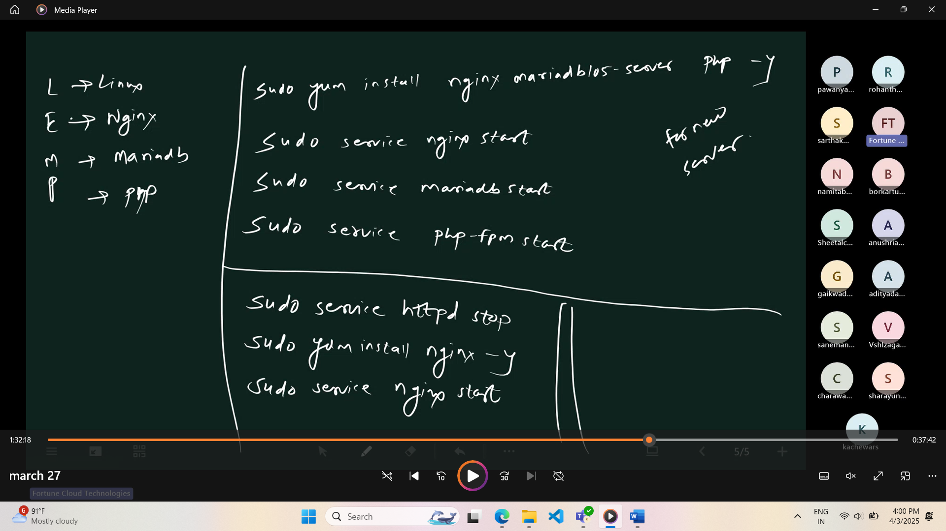

If something not works in linux:



Lemp in Ubuntu:

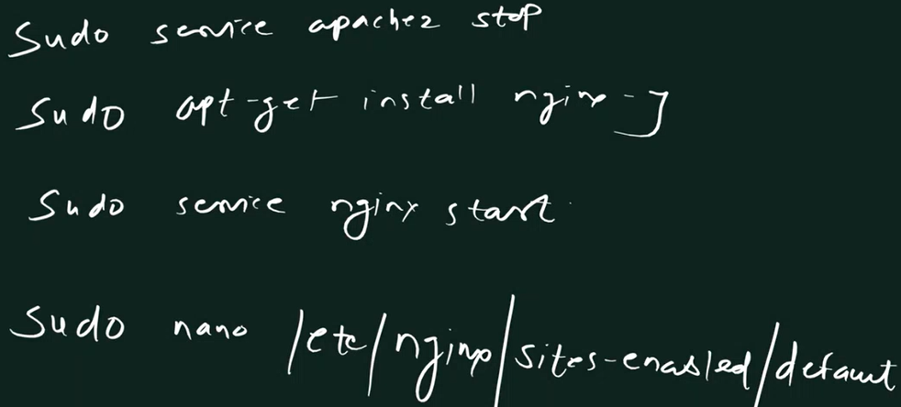

To start the php file:#696

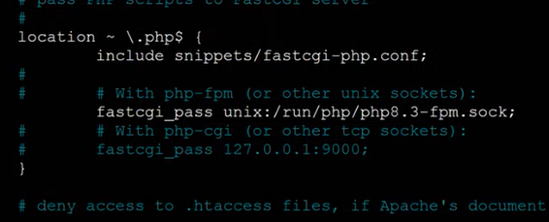

If we see php error:like this , use below code to correct it.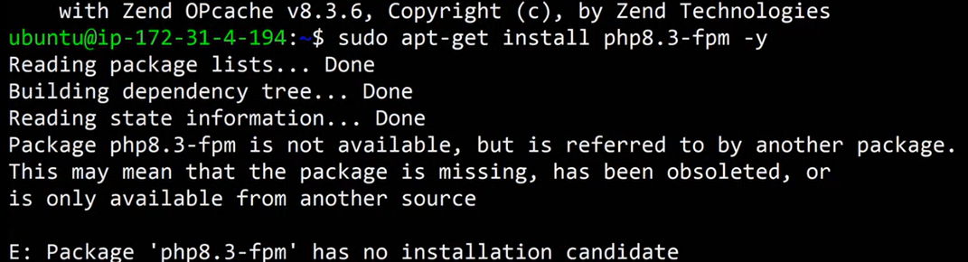If ubuntu show error:



#999

Create: 

**To see database:** 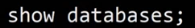

**To Set the Password :** 

**Create table:** 

to see details: 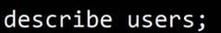 OR desc users;

to see the input content of the table : 

Insert content in table: 

To find the max , min ,average value :



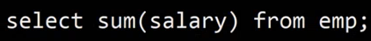



**To have condition with minimum value:**



**Another example (using alphabet in the character):** 

**Its used for one condition with another condition:**



To add a column to an existing table: 

**To update any column by adding extra features:** 

***Another example to update the varchar value:***



**Drop a column in the table:** 

**Rename the column name :**



*Changes inside the table:*



Another Example:



Update all the column element in one go : 

**To add unique key to the tables column:**



**To delete something:**



To delete primary key : 

**To delete more than one entry:**



**To add foreign key: in which reference users is the entry of another table.**



**To see constraint name with details:**

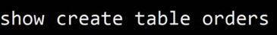**;**

**Delete constraint :** 

To Truncate the data: 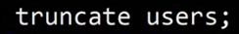

To drop the table: 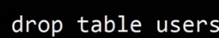

To Backup in EC2:



**Drop the Database:** 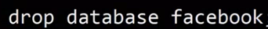

Restore the data in another database:



**To add primary key to a existing table to a column :**



**Php -Mysql :**



**WordPress:**



**For the FTP Server:**



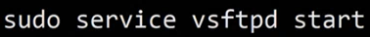

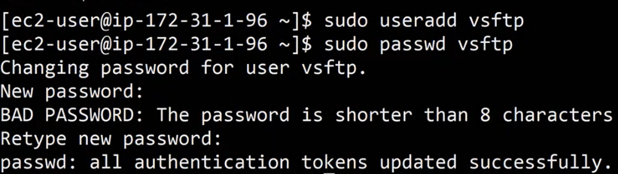



**For the node server:**







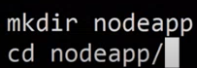



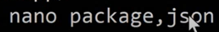



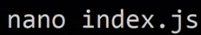

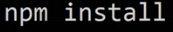

**To see all the task going on in background:**

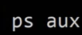**To filter our search for above command we use grep name**



**Now to kill the process after getting the name and id :** 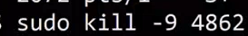

**To run node in Background :**



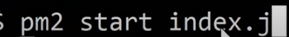

**#188: Nginx Server for Node files run if 3000❌.**

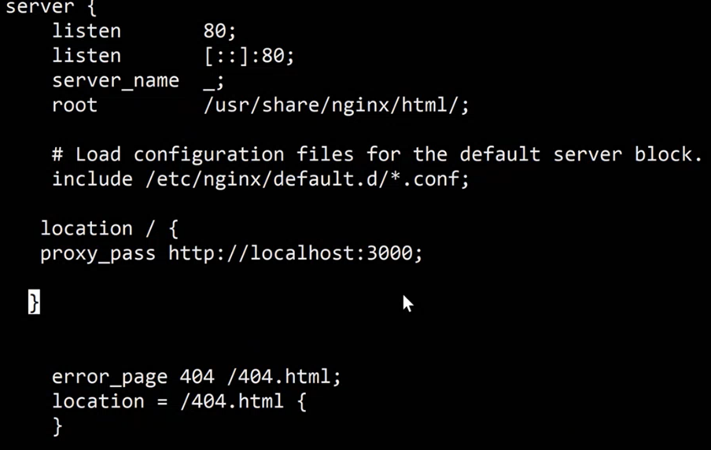



**For Python on the server :**

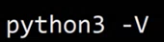



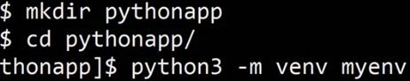

*For the Activation of Packages*

For Virtual Envirnment

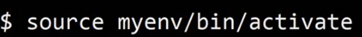

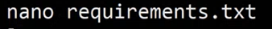



**Used to run the python file in the forethground:**



**Or**



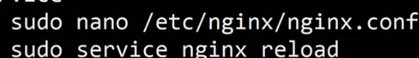Figure :used to run in background

**To kill the process:**





**#333 : VPC : IP-Variation**



**#555**

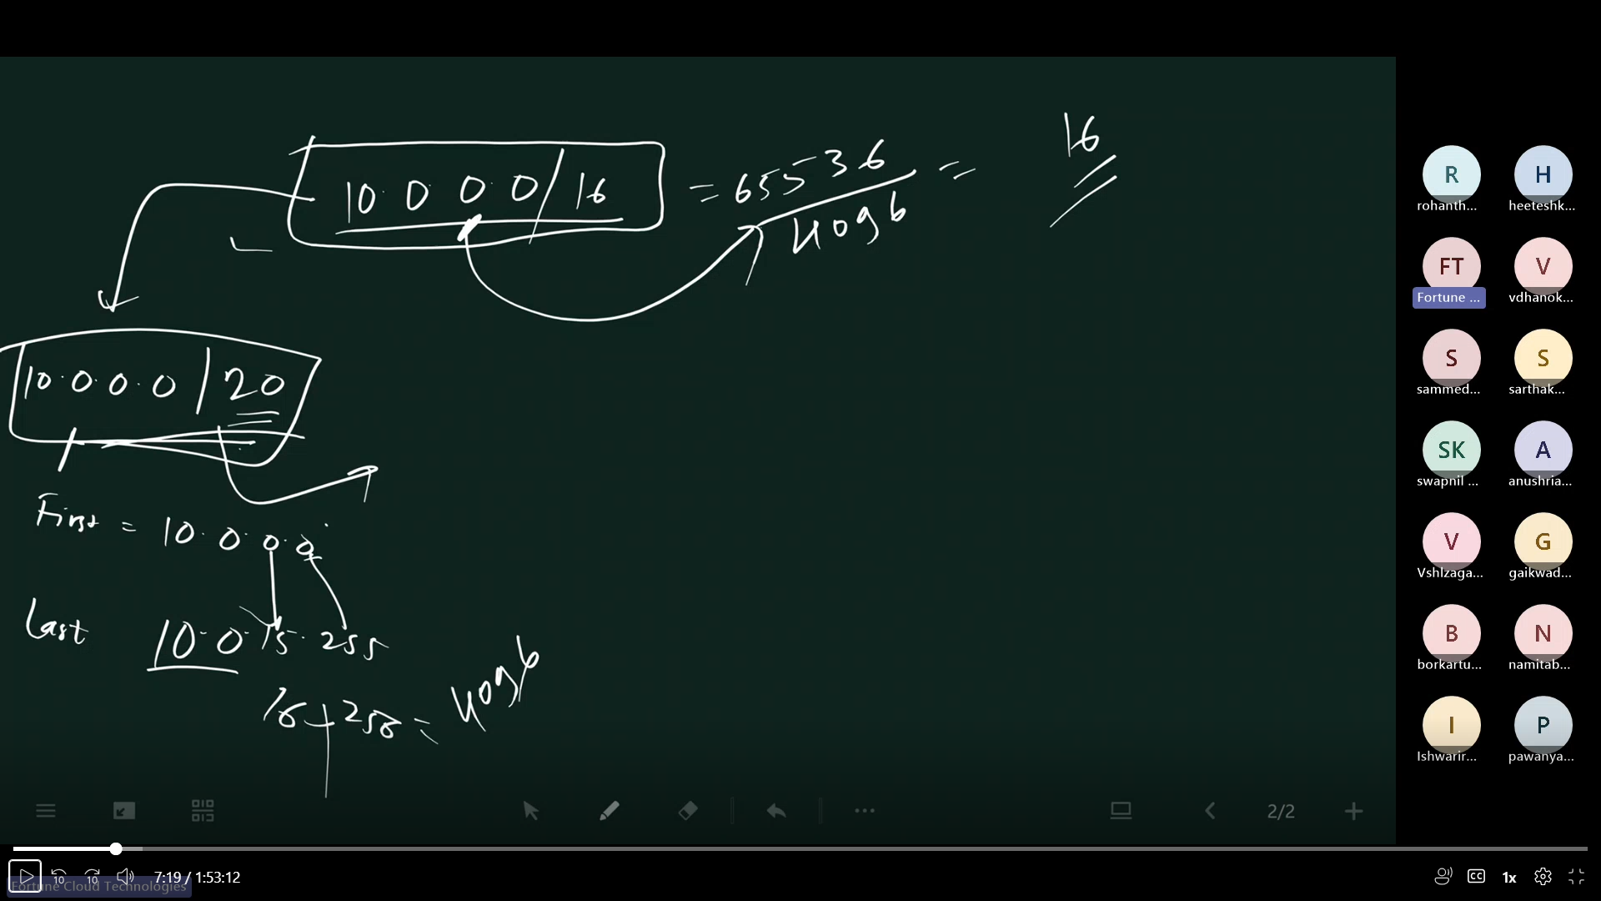

**# 111**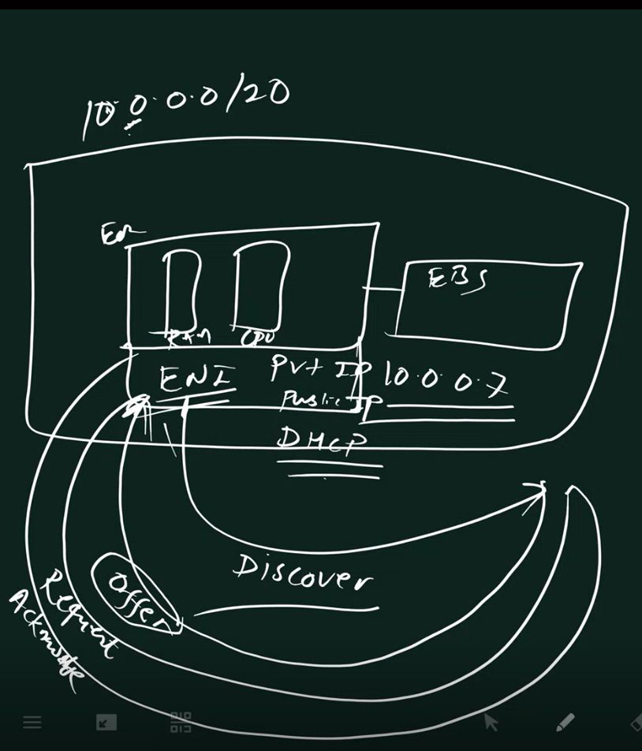

**#777**

**l**

**#888**

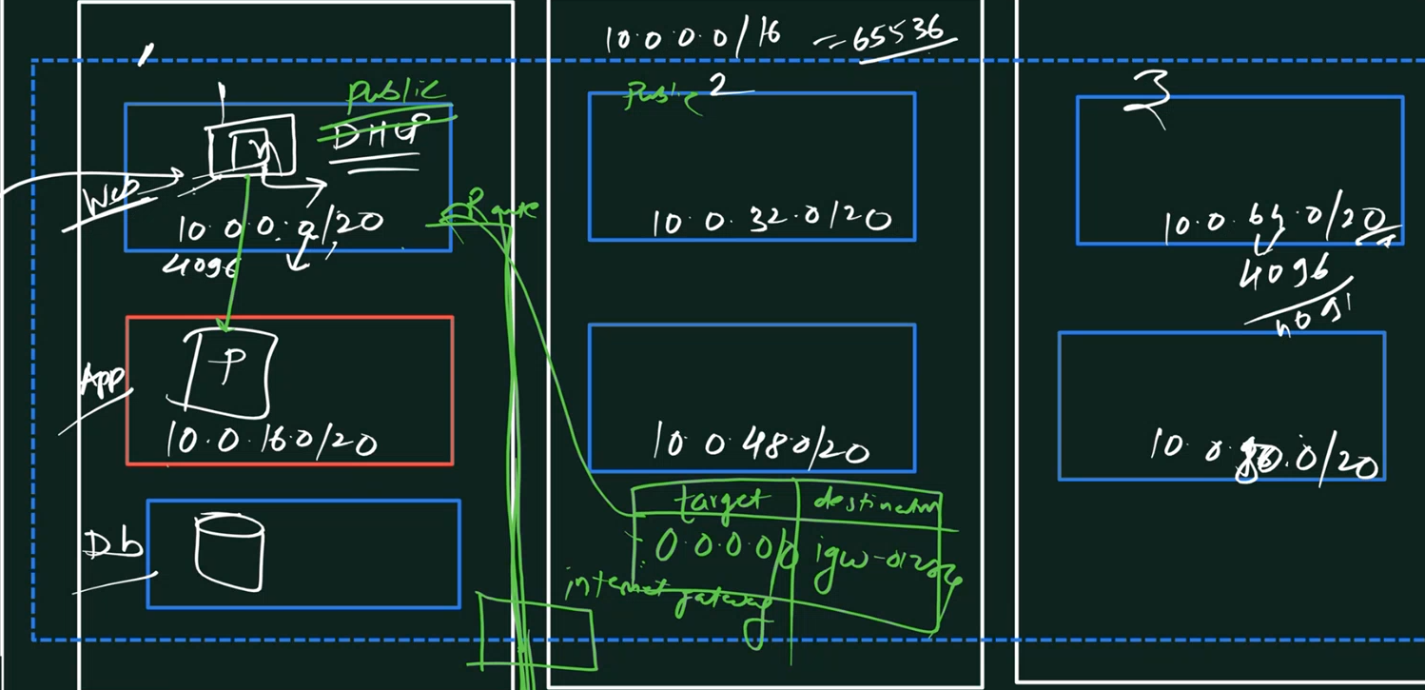

**Revision of CIDR distribution**

**# 1000**

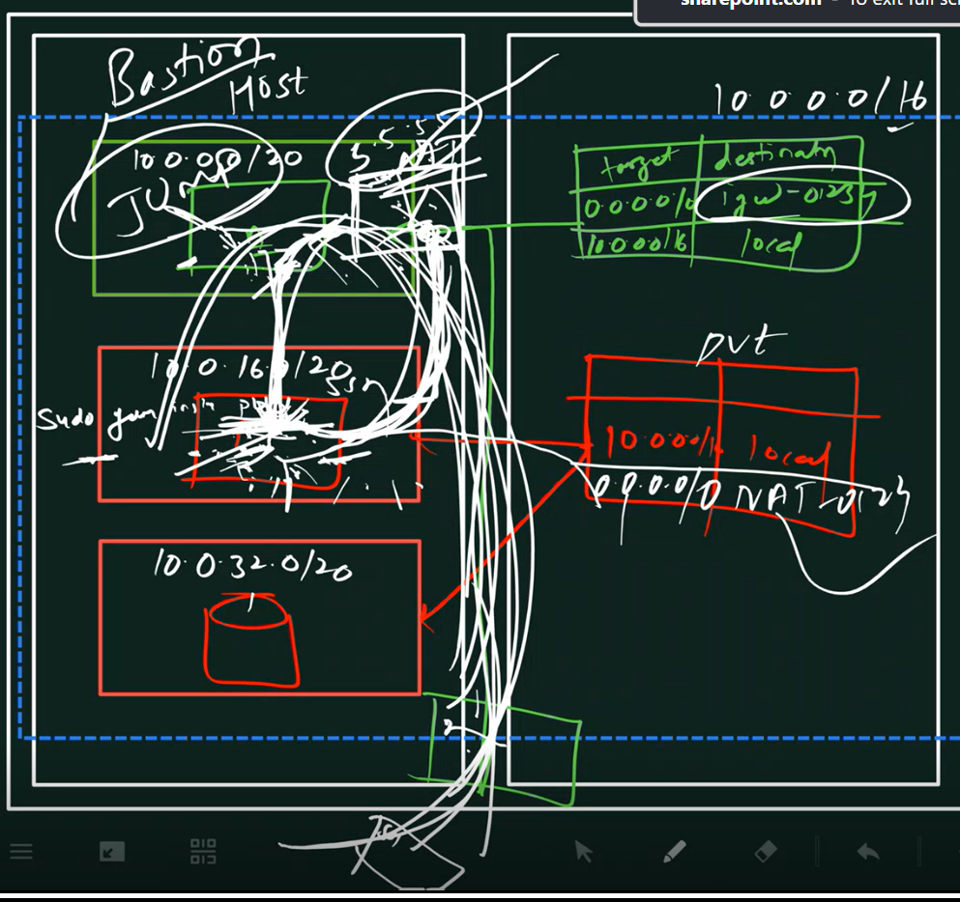

**#1001**

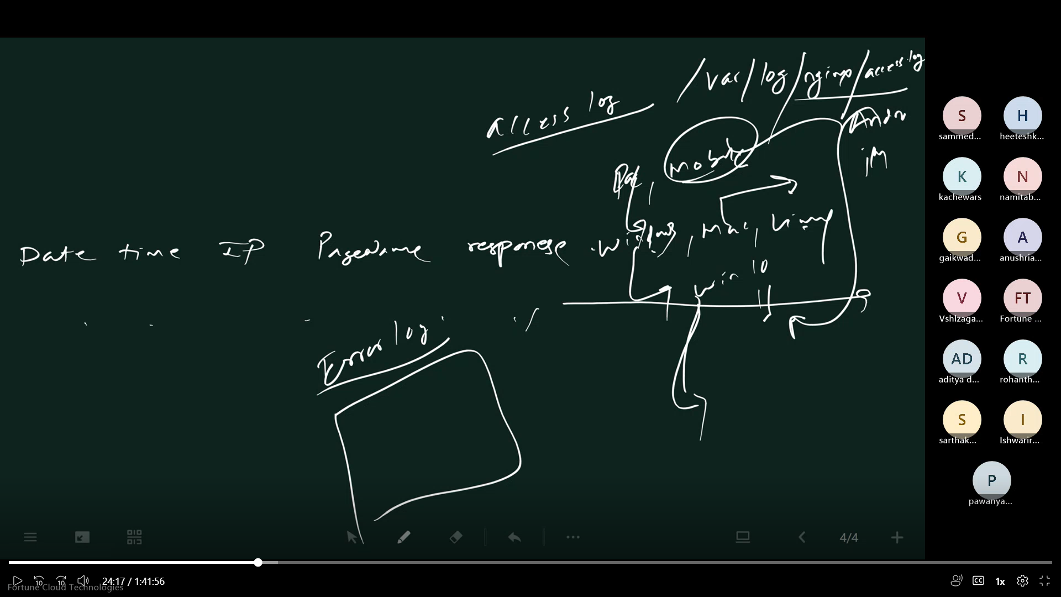

**#1002**

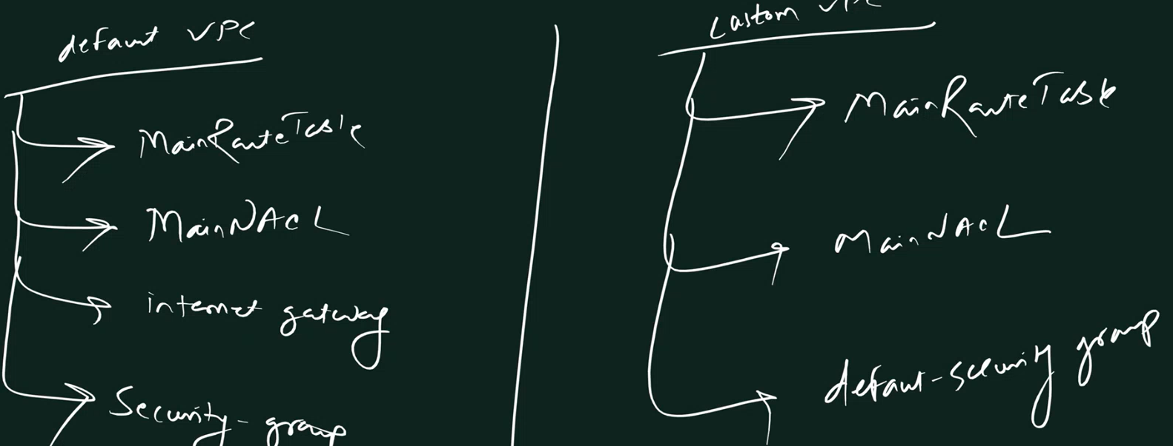

**#1003**

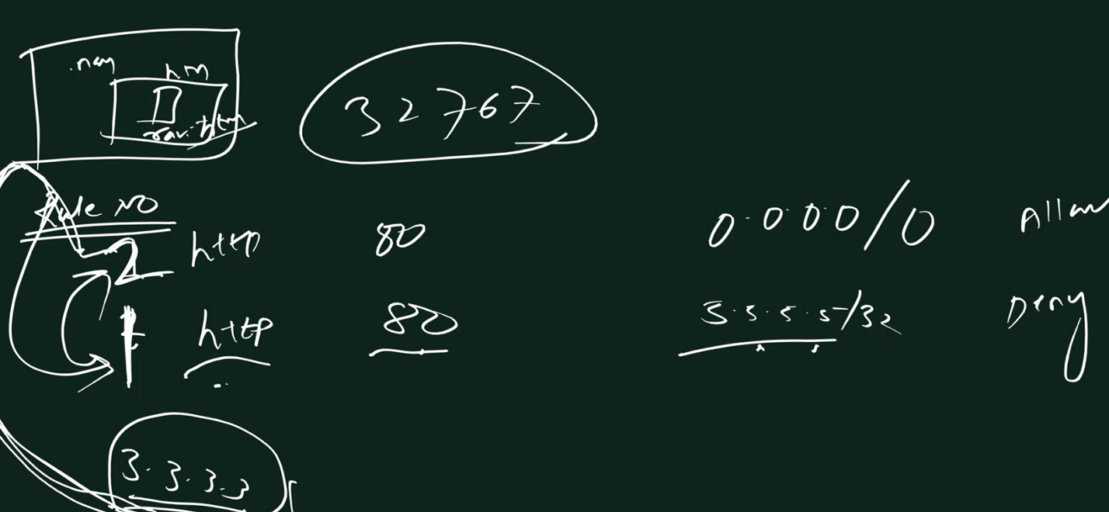

**#1003**

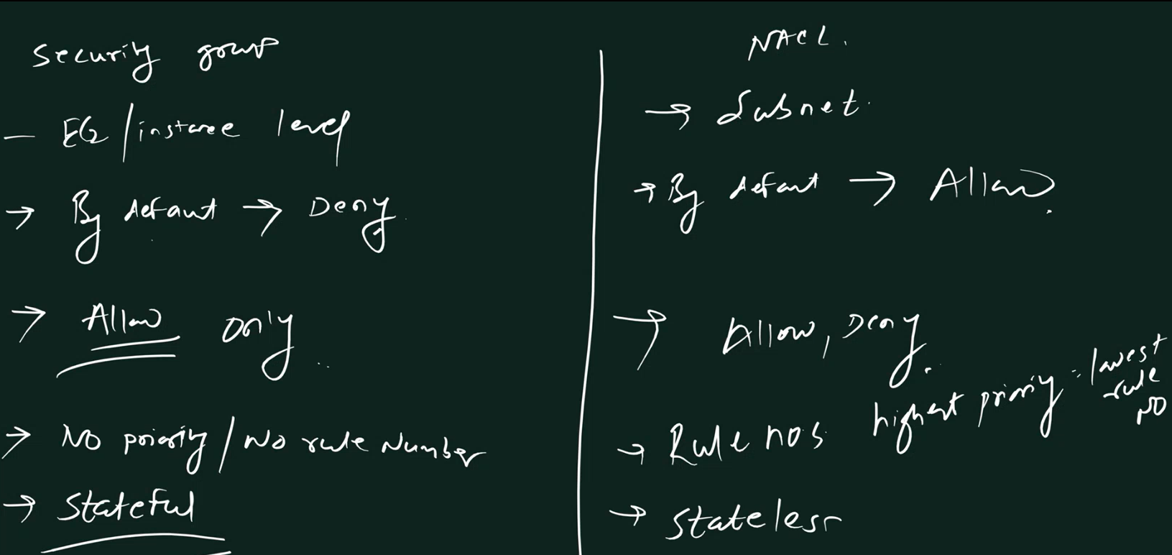

**#1004**

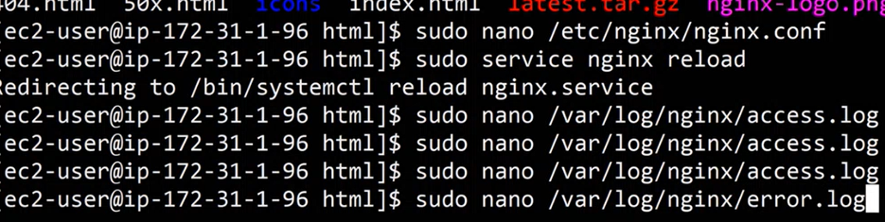

**#1005**



**#1006**

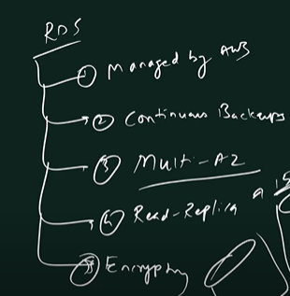

**#1007**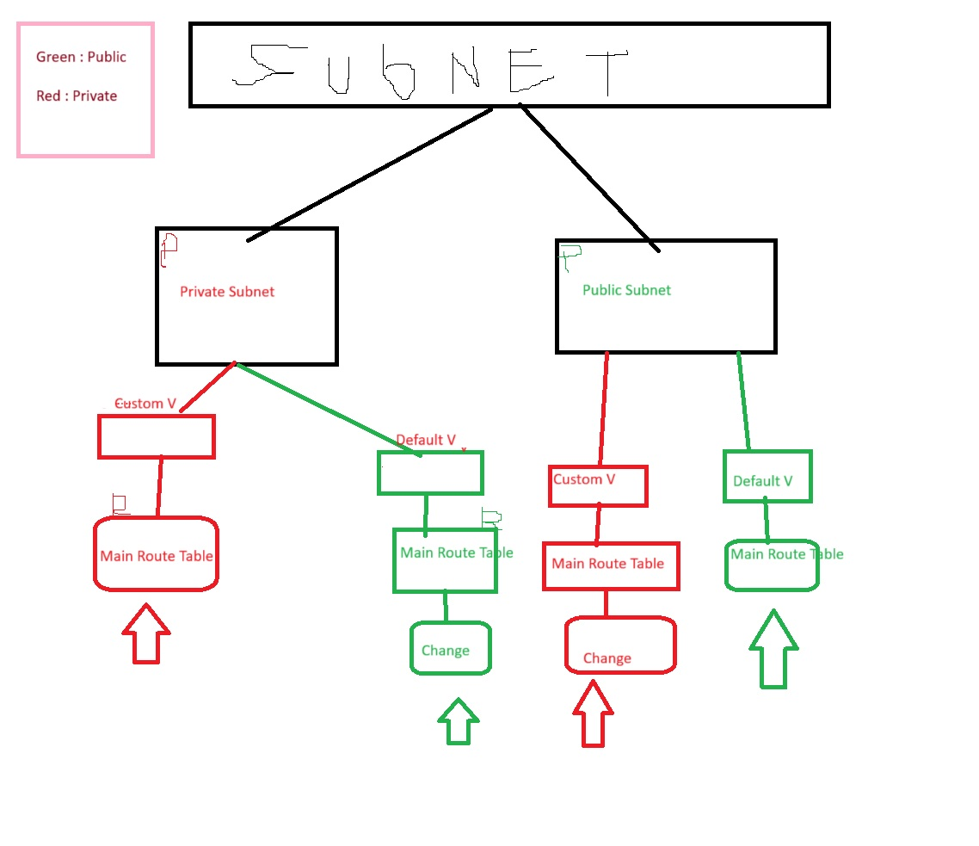

**#1008**

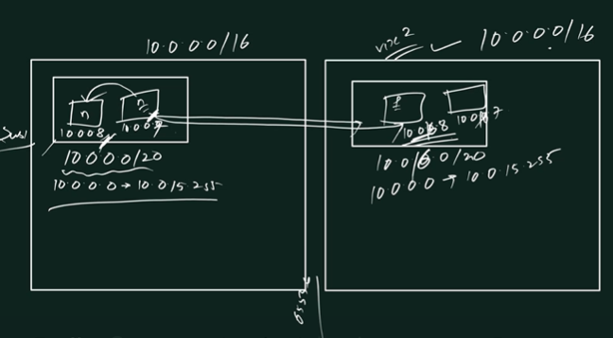

**#1009**